**Corrine Kiwanuka**

PLP sample project github repository: <https://github.com/Kiwanuka001/PLP-Sample-project.git>

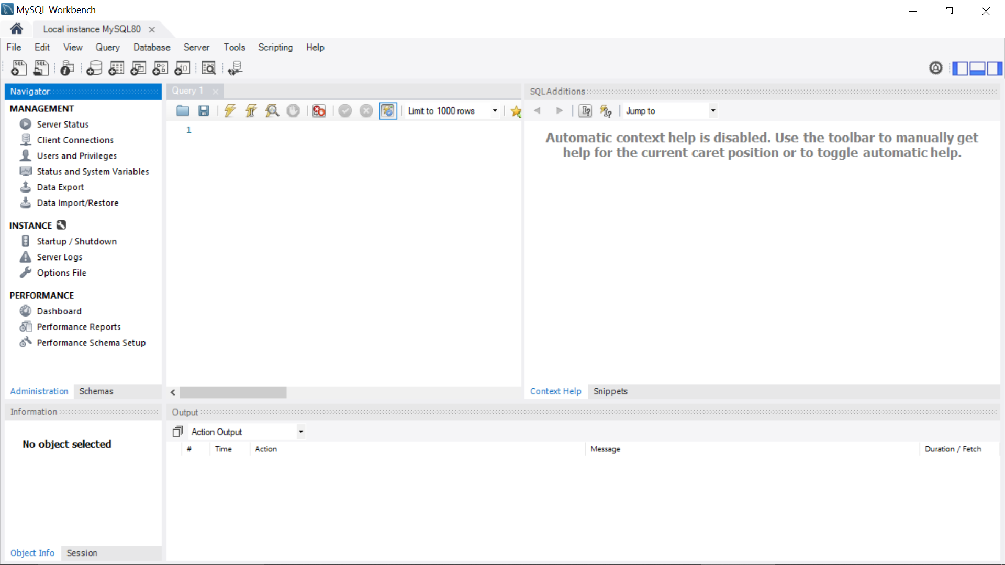

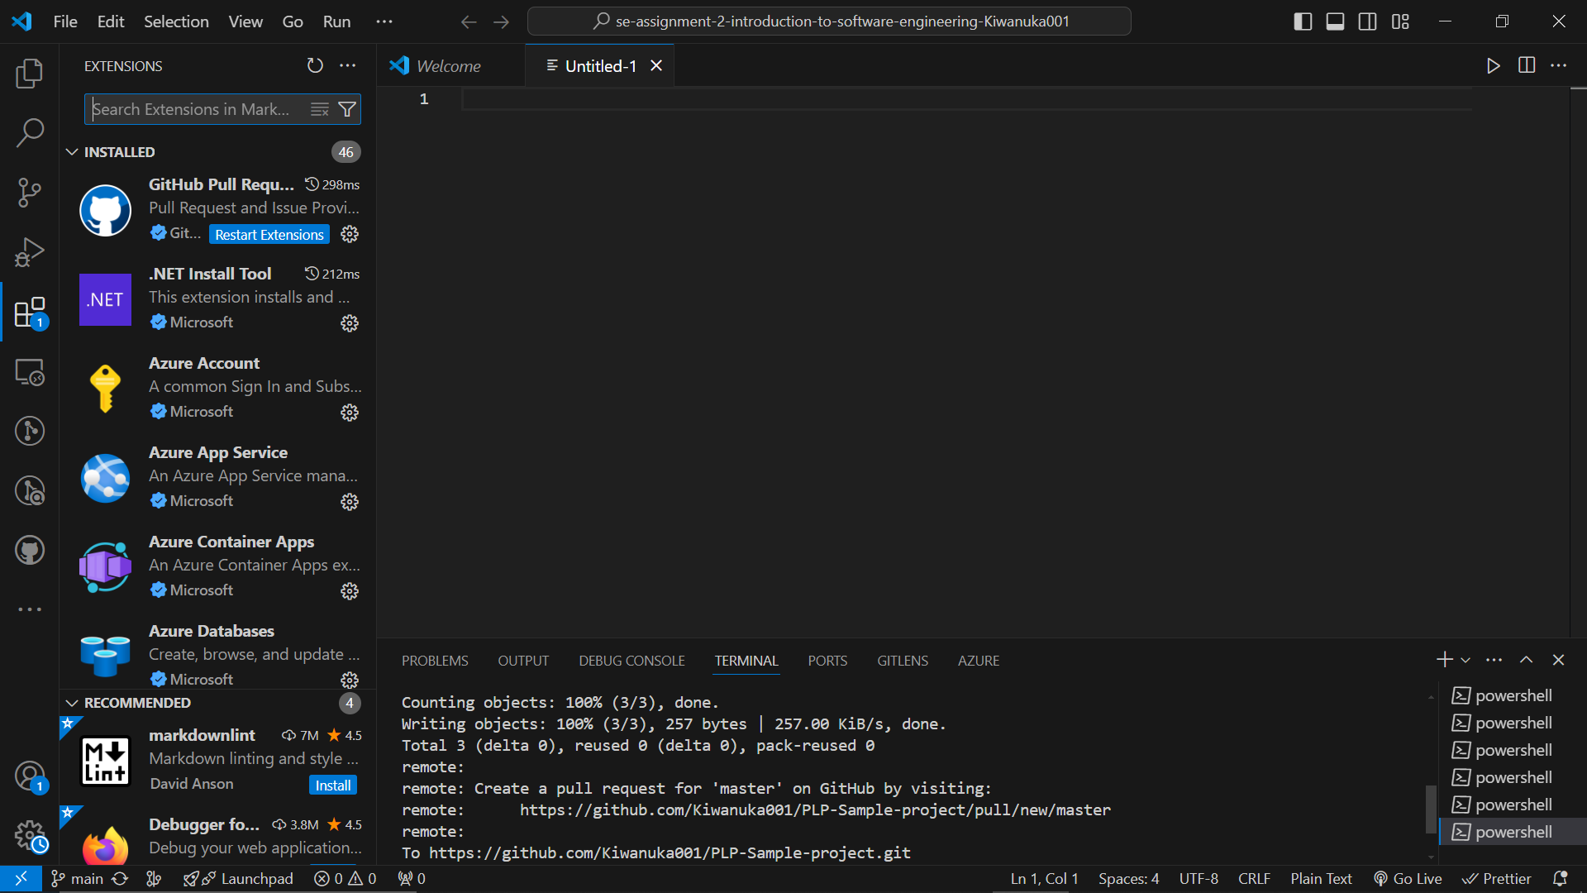

I was able to install Python, Flutter, Git as well as MySQL

.

I experienced challenges most especially when installing Flutter due to my error in showing the correct path on the variables settings. I had to use chatgpt to help set me straight on this which has been a success.

Challenges that I can say I have experienced is not knowing how to use the tools as well as seeing them as too complex. I had to watch a few youtube videos for this